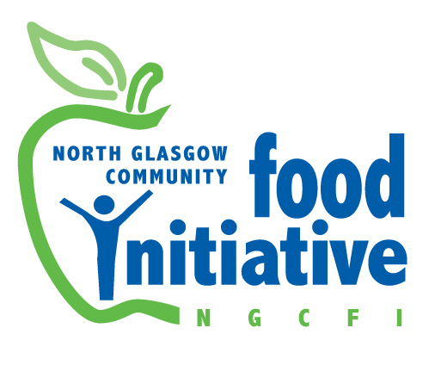
Application Pack

St Andrew's Church

Liddesdale Square, Milton
Glasgow, G22 7BT

Tel 0141 772 0229
Office Mobile: 07422 375523
Email: admin@ngcfi.org.uk
www.ngcfi.org.uk

Charity No SCO36842
Company Reg No 290958

September 2025

Dear Applicant,

Vacancy: Volunteer Co-ordinator (part-time)

Thank you for your expression of interest in this post and North Glasgow Community Food Initiative (NGCFI).

You should have the following papers with the email / web site download:
- Job Description and Person Specification and Background to the organisation on
- Application Form and Equal Opportunities monitoring form

Salary and Hours are set out in the advert and Job Description.
There maybe some evening and occasional evening and weekend work for which a TOIL system is in place. We require individuals to be flexible in their working hours to suit the needs of the organisation and our service users.

Contract
A contract of employment will be offered to the successful candidate in line with dates set out in the advert.

Application Procedure - Please email your CV together with a written statement explaining how your meet each of the essential criteria listed within the Person Specification.

Deadline for application forms: 22nd September 2025

Forms can be emailed, indicating in the email subject line: Application for [the post you are applying for]. Please also complete the Equal Opportunities monitoring form which will not be used for selection purposes.

Interview on: Interview date TBC

If you have not heard by then you may assume that on this occasion you have not been successful in being invited for interview. Those invited for interview will be sent a Self Declaration Form – as these posts are Protected Adult and work with Children positions.

Equal Opportunities
As an organisation we are committed to equal opportunities and encourage applications
from all sectors of the community. Please call the office if you would like a copy of our
equal opportunities policy.

Please contact our office should you require further information.

Please send a covering letter and your CV to our email: admin@ngcfi.org.uk

Best Wishes

Martha Wardrop
Chairperson of the Board of Directors

Volunteer Coordinator Job Description

Employer: North Glasgow Community Food Initiative
Salary:

Hours: 18 hours per week 1st October- 31st March 2025

Annual Salary: Pro Rata £13,409 (FTE £23,466) + 7% pension contribution

Leave: 25 days Annual Leave Pro Rata and 12 Public Holidays Pro rata
Employee Benefits: You will have access to free personal development opportunities and training, casual dress, a supportive team, access to Turadh holiday scheme and flexible working.
Responsible to: The Project Manager
Funded by: Agnes Hunter Trust, The National Lottery Community Action, Hubbub Investment Fund

Job Purpose
The Volunteer Co-ordinator provides volunteer management across our three Food Hubs in Milton, Royston and Springburn. The role ensures volunteers are welcomed, supported, trained, and placed into meaningful roles, with a particular focus on supporting people with disabilities, those from disadvantaged backgrounds, those in recovery, those experience mental health challenges and individuals seeking skills and experience for future employment.
Working closely with the Food Hub Managers, the postholder will oversee recruitment, retention, and recognition of volunteers; organise training and wellbeing activities, and provide individual support where needed. They will also ensure robust monitoring, evaluation, and reporting to funders, demonstrating the positive outcomes achieved for volunteers and the wider community.

Main Duties
- Volunteer Recruitment, Induction & Placement
- Identify volunteer gaps and opportunities across the Food Hub (Community Café, Pantry, Fridges, Gardening, Cookery Club).
- Recruit, induct, and place volunteers, ensuring roles match skills, interests, and support needs.
- Manage role descriptions and use the platform Volunteer Glasgow to manage new requests
- Promote volunteering opportunities through networks, marketing, social media, and community outreach.
- Volunteer Support & Retention
- Provide regular 1:1 support, weekly check-ins, and six-monthly reviews with volunteers.
- Support volunteers with disabilities and higher support needs to access meaningful opportunities.
- Offer recognition and celebration through events, excursions, awards, and newsletters.
- Promote cultural understanding, inclusion, and integration across all volunteer activities.
- Organise volunteer celebration days twice per year, include one during Volunteer Celebration Week
- Company Volunteering
- Develop and deliver the company volunteering strand in line with NGCFI’s business plan, ensuring it contributes to both social impact and income generation.
- Build and maintain partnerships with local and national companies to increase opportunities for corporate volunteering and sponsorship.
- Coordinate and manage company volunteer days, working closely with NGCFI staff to plan meaningful, well-supported activities across the Food Hub.
- Use NGCFI’s company volunteering brochure and booking systems to promote opportunities, manage enquiries, and ensure smooth administration.
- Evaluate and report on company volunteering activities, capturing outcomes for both the business partners and the community.

- Training & Skills Development
- Organise training sessions and workshops, including food hygiene, first aid, trauma awareness, safeguarding, anti-racism, mindfulness, and employability support.
- Enable volunteers to develop confidence, transferable skills, and leadership qualities.
- Provide support with CVs and references, helping volunteers progress into employment, education, or further opportunities.
- Programme Delivery & Community Engagement
- Signpost individuals to relevant support services (e.g. housing, energy advice, mental health).
- Support and participate in wider community-led events and Food Hub activities.
- Monitoring, Evaluation & Reporting
- Maintain accurate volunteer records, including numbers, hours, demographics, retention, and training completed.
- Collect feedback and track outcomes such as confidence, wellbeing, social connections, and skills gained.
- Provide evidence and written reports for funders, ensuring all outcome targets are met (Agnes Hunter, Hubbub, National Lottery).
- Collaboration & Organisational Responsibilities
- Work closely with NGCFI staff to ensure volunteers are supported in their placements.
- Ensure safeguarding, PVG checks, Health & Safety, and GDPR/Data Protection compliance.
- Contribute to funding applications, volunteer-related policy development, and strategy reviews (recruitment, support, retention).
- Represent NGCFI positively in external meetings, partnerships, and forums.
- Lead on Investing in Volunteers Award

Person Specification
Essential
- Understanding and commitment to the values and aims of NGCFI.
- Minimum of two years’ experience in volunteer recruitment, induction, and support.
- Experience of working with people with disabilities and/or from disadvantaged communities.
- Experience of delivering and facilitating training, group activities, or wellbeing sessions.
- Strong organisational skills with ability to manage multiple activities and deadlines.
- Excellent interpersonal and communication skills with a person-centred approach.
- IT competence (MS Office, databases, social media, website updates).
- Experience in monitoring and evaluation, including tracking outcomes for volunteers.
Desirable
- Knowledge of community food projects, food redistribution, or community fridge operations.
- Experience of Health & Safety, safeguarding, and risk assessments.
- Understanding of community development and community health issues.
- Experience of producing case studies, newsletters, or volunteer stories.
- Driving licence and access to a car / ability to drive a van.

